User Manual 1

1 Document Information 2

1.1 Document Control Information 2

1.2 Revision History 2

1.3 Approvals 3

1.4 Document Scope 3

2 Introduction 3

2.1 System Overview 3

2.2 Target Audience 4

2.3 System Requirements 4

2.3.1 Hardware Requirements 4

2.3.2 Software Requirements 5

2.4 Conventions and Terminology 5

2.4.1 Document Conventions 5

2.4.2 Basic Glossary 6

2.4.3 Model Input and Output Glossary 7

3 Getting Started 10

3.1 Accessing the System 10

3.2 User Interface Overview 11

3.2.1 Navigation Menu 11

3.2.2 Main Content Area 11

3.3 Login and Register 11

3.3.1 Logging Into the System 11

3.3.2 Register of the System 12

3.3.3 Password Reset 13

4 Core Functionality 13

4.1 Data Upload and Format Validation 13

4.2 Dependent Variable Selection and Analysis 14

4.3 Key Feature Analysis 14

4.4 Data Format Specification 15

4.5 Grid Data Heatmap Display 15

4.6 Model Performance Comparison 16

4.7 Predict 16

4.7.1 Predict results display 16

4.7.2 Predict results export 17

5 Best Practices 17

5.1 System Usage Recommendations 17

5.2 Data Interpretation Guidelines 17

5.3 Troubleshooting Tips 18

6 Appendices 18

6.1 Frequently Asked Questions 18

6.2 Error Message Reference 19

User Manual

1. Document Information
   1. Document Control Information

|  |  |
| --- | --- |
| **Document Title** | Research and Application of Urban  Land Use Change Detectiont -- User Manual |
| **Version** | 1.2 |
| **Date** | May 30, 2025 |
| **Status** | Completed |
| **Document Owner** | Project Team |

* 1. Revision History

|  |  |  |  |
| --- | --- | --- | --- |
| **Version** | **Date** | **Author** | **Description** |
| 1.0 | May 6, 2025 | HongLin Wu | Initial Submission |
| 1.1 | May 15,2025 | ZhiXin Peng | Updated with core functionality details |
| 1.2 | May 30,2025 | HongLin Wu | Completed frontend implementation and UI doc  umentation |

* 1. Approvals

|  |  |  |  |
| --- | --- | --- | --- |
| **Name** | **Role** | **Signature** | **Date** |
| ZhiXin Peng | Project Manager |  | May 30, 2025 |
| HongLin Wu | Team Member |  | May 30, 2025 |
| Yangyang Xu | Team Member |  | May 30, 2025 |
| Yang Liu | Team Member |  | May 30, 2025 |

* 1. Document Scope

This manual provides comprehensive guidance for end-users(Urban planners) and administrators of the Research and Application of Urban Land Use Change Detection Project, including system overview, operation instructions, and best practices for all functional modules of the system.

1. Introduction
   1. System Overview

This project aims to provide a platform for the analysis of the solar and thermal data in Shanghai. It mainly includes a heat map showing the grid data of Shanghai's solar and thermal aspects, and can be used to identify the key influencing factors of the solar and thermal dependent variables in the Excel data uploaded by users. It also provides solar and thermal predictions using the Kan model, as well as a comparison between the Kan model and other baseline models, aiming to help urban planning personnel analyze the livability level of a certain area in Shanghai through solar and thermal data.

* 1. Target Audience

- Urban planners

- Environmental researchers

- Policy makers

- Data analysts

- General users interested in urban livability

* 1. System Requirements
     1. Hardware Requirements

|  |  |
| --- | --- |
| **Component** | **Requirement** |
| **Server** |  |
| Processor | Intel Xeon E5-2650 v4 or higher |
| Memory | 4GB RAM or higher |
| Storage | 60GB RAM or higher |
| Network | 10Mbps connection or higher |
| **Client** |  |
| Processor | Intel Core i5 (8th gen) or higher |
| Memory | 4GB RAM or higher |
| Display | Recommend 1920 x 1080 resolution  or higher |

* + 1. Software Requirements

|  |  |
| --- | --- |
| **Component** | **Requirement** |
| **Server** |  |
| Operating System | Windows Server 2019 or later |
| Database | SQLite 3.3 or later |
| **Client** |  |
| Operating System | Windows 10/11  macOS Monterey or later |
| Web Browser | Google Chrome (latest 2 versions)  Mozilla Firefox (latest 2 versions)  Microsoft Edge (latest 2 versions)  Safari (latest 2 versions) |

* 1. Conventions and Terminology
     1. Document Conventions

- **Bold** : Indicates menus, buttons, or interface elements

- *Italic* : Indicates specially emphasized information

* + 1. Basic Glossary

|  |  |
| --- | --- |
| **Term** | **Definition** |
| Dependent Variable | The main variable to be analyzed (e.g., surface temperature) |
| Independent Variable | Factors that may influence the dependent variable |
| MLP | Multilayer Perceptron,is a type of neural network composed of multiple layers of interconnected nodes that can model complex nonlinear relationships in data. |
| RF | Random Forest , is an ensemble learning method that builds multiple decision trees and combines their outputs to improve predictive accuracy and reduce overfitting. |
| KAN | a neural network model inspired by the Kolmogorov–Arnold representation theorem, designed to provide more interpretable and efficient function approximations. |
| Baseline | a simple or previously established model used as a reference point to evaluate the performance of more advanced models. |
| Gridded Data | spatial data divided into uniform grid cells, where each cell contains aggregated or averaged values representing a specific geographic area. |
| Interpretable Prediction | model outputs that not only provide accurate forecasts but also offer insights into the contribution and impact of input features. |

* + 1. Model Input and Output Glossary

| **Property** | **Units** | **Definition** | **Input/Output** |
| --- | --- | --- | --- |
| Land01 | % | The percentage of residential land area to grid area | Input |
| Land02 | % | The percentage of commercial service land area to grid area | Input |
| Land03 | % | The percentage of industrial land area to grid area | Input |
| Land50234 | % | The percentage of land used for education, scientific research, medical treatment, sports and culture in the grid area | Input |
| Land505 | % | The percentage of park and green space area to grid area | Input |
| NDVI_MEAN | Ratio, value is between -1 and 1 | Normalized Difference Vegetation Index | Input |
| sidewalk_MEAN | % | Raster average street view crosswalk ratio | Input |
| building_MEAN | % | Raster average street view building facade ratio | Input |
| vegetation_MEAN | % | Grid average street view green rate | Input |
| sky_MEAN | % | Raster average street view sky ratio | Input |
| POI餐饮服务_n | one | Number of catering service facilities in each grid | Input |
| POI风景名胜_n | one | The number of scenic spots and facilities in each grid | Input |
| POI公司企业_n | one | The number of company facilities in each grid | Input |
| POI购物服务_n | one | Number of shopping service facilities in each grid | Input |
| POI科教文化_n | one | Number of scientific, educational and cultural facilities in each grid | Input |
| POI商务住宅_n | one | Number of commercial and residential facilities in each grid | Input |
| POI生活服务_n | one | Number of living service facilities in each grid | Input |
| POI体育休闲_n | one | Number of sports and leisure facilities in each grid | Input |
| POI医疗保健_n | one | Number of medical and health facilities in each grid | Input |
| POI政府机构团体_n | one | Number of government agency facilities in each grid | Input |
| 不透水面比例 | % | Ratio of impervious surface area to grid area | Input |
| 建筑密度 | % | Ratio of building base area to grid area | Input |
| 容积率 | meter | Total building volume/total grid area (1km*1km) | Input |
| railway_m | meter | Total length of railway in each grid | Input |
| Subway_m | meter | Total length of subway in each grid | Input |
| car_road_m | meter | Total length of roadway in each grid | Input |
| high_grade_road_m | meter | Total length of high-grade road in each grid | Input |
| nighttime_light_dnb | nanoWatts/sr/cm^2 | Nighttime light dnb radiation value in each grid | Output |
| lst_day_c | ℃ | Daytime average surface temperature in each grid | Output |
| lst_night_c | ℃ | Nighttime average surface temperature in each grid | Output |

1. Getting Started
   1. Accessing the System

Open your web browser and navigate to the project URL:

http://43.142.162.35:5173

For local deployment, run `npm install` and `npm run dev` in the project directory

* 1. User Interface Overview
     1. Navigation Menu

Located on the left of the page

Provides access to main modules: Analysis, Comparison, Grid, Prediction.



* + 1. Main Content Area

Displays the selected modules content, such as data upload, analysis results, or maps

* 1. Login and Register
     1. Logging Into the System

Click the “Login” button

Enter your username and password

Click “Submit” to access the system



* + 1. Register of the System

Click the register button

Fill the email and password, after receiving the code, fill the code field and submit to register.



* + 1. Password Reset

On the login page, click “Forgot Password”

Enter your registered email to receive a reset link

0

1. Core Functionality
   1. Data Upload and Format Validation

- Click “Upload Data File” to select an Excel file (.xlsx or .xls)

- The system validates the file format and required fields automatically

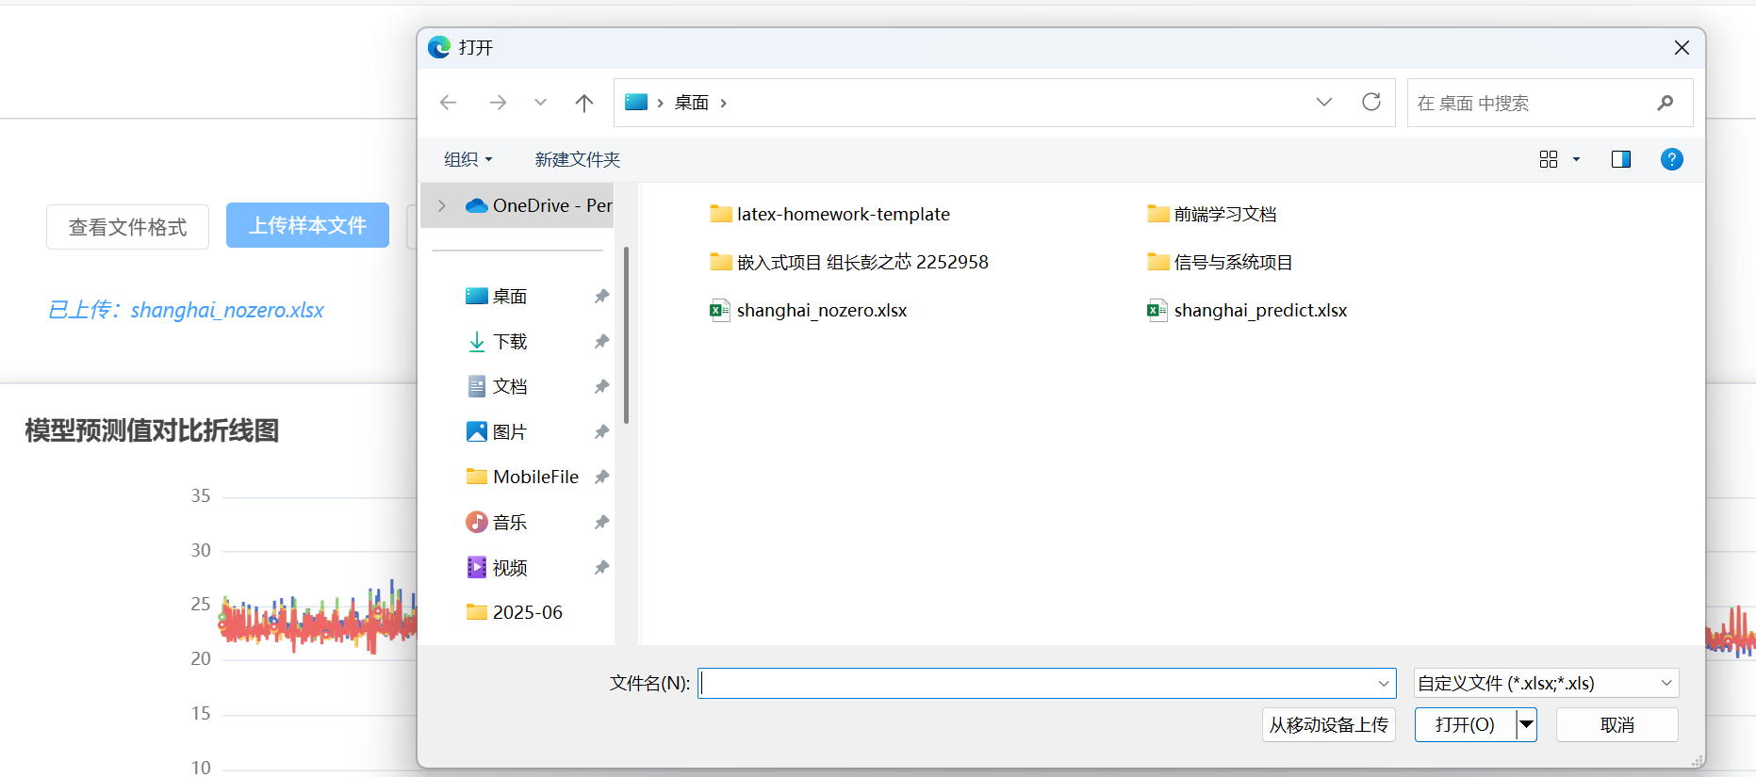

* 1. Dependent Variable Selection and Analysis

- Use the dropdown to select the dependent variable (e.g., surface temperature, nighttime light)

- Click “Analyze” to start the analysis



* 1. Key Feature Analysis

- Results are displayed in a table with feature importance scores

- Progress bars visualize the relative importance of each feature

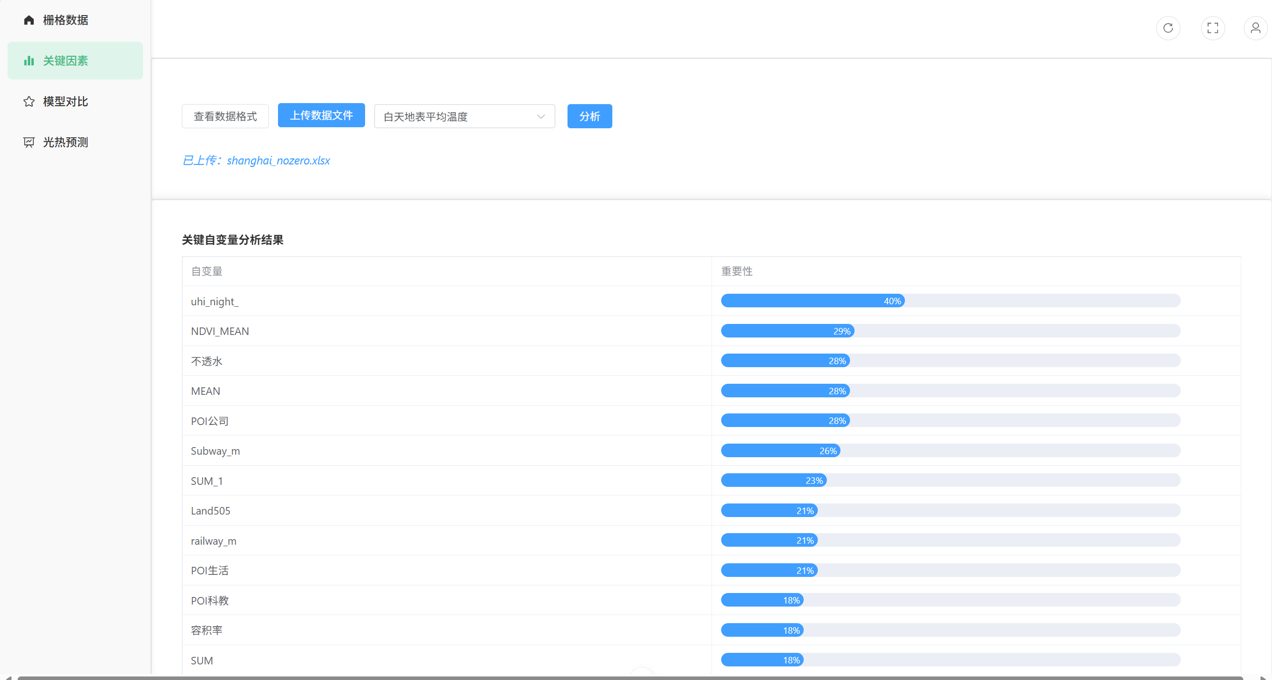

* 1. Data Format Specification

- Click “View Data Format” for required fields

- Example fields: Land01~Land05, NDVI_MEAN, sidewalk_M, building_M, vegetation, sky_MEAN, POI categories, impervious surface, building density, floor area ratio, transportation distances, high-grade roads, nighttime light, lst_day_c, lst_night_c.

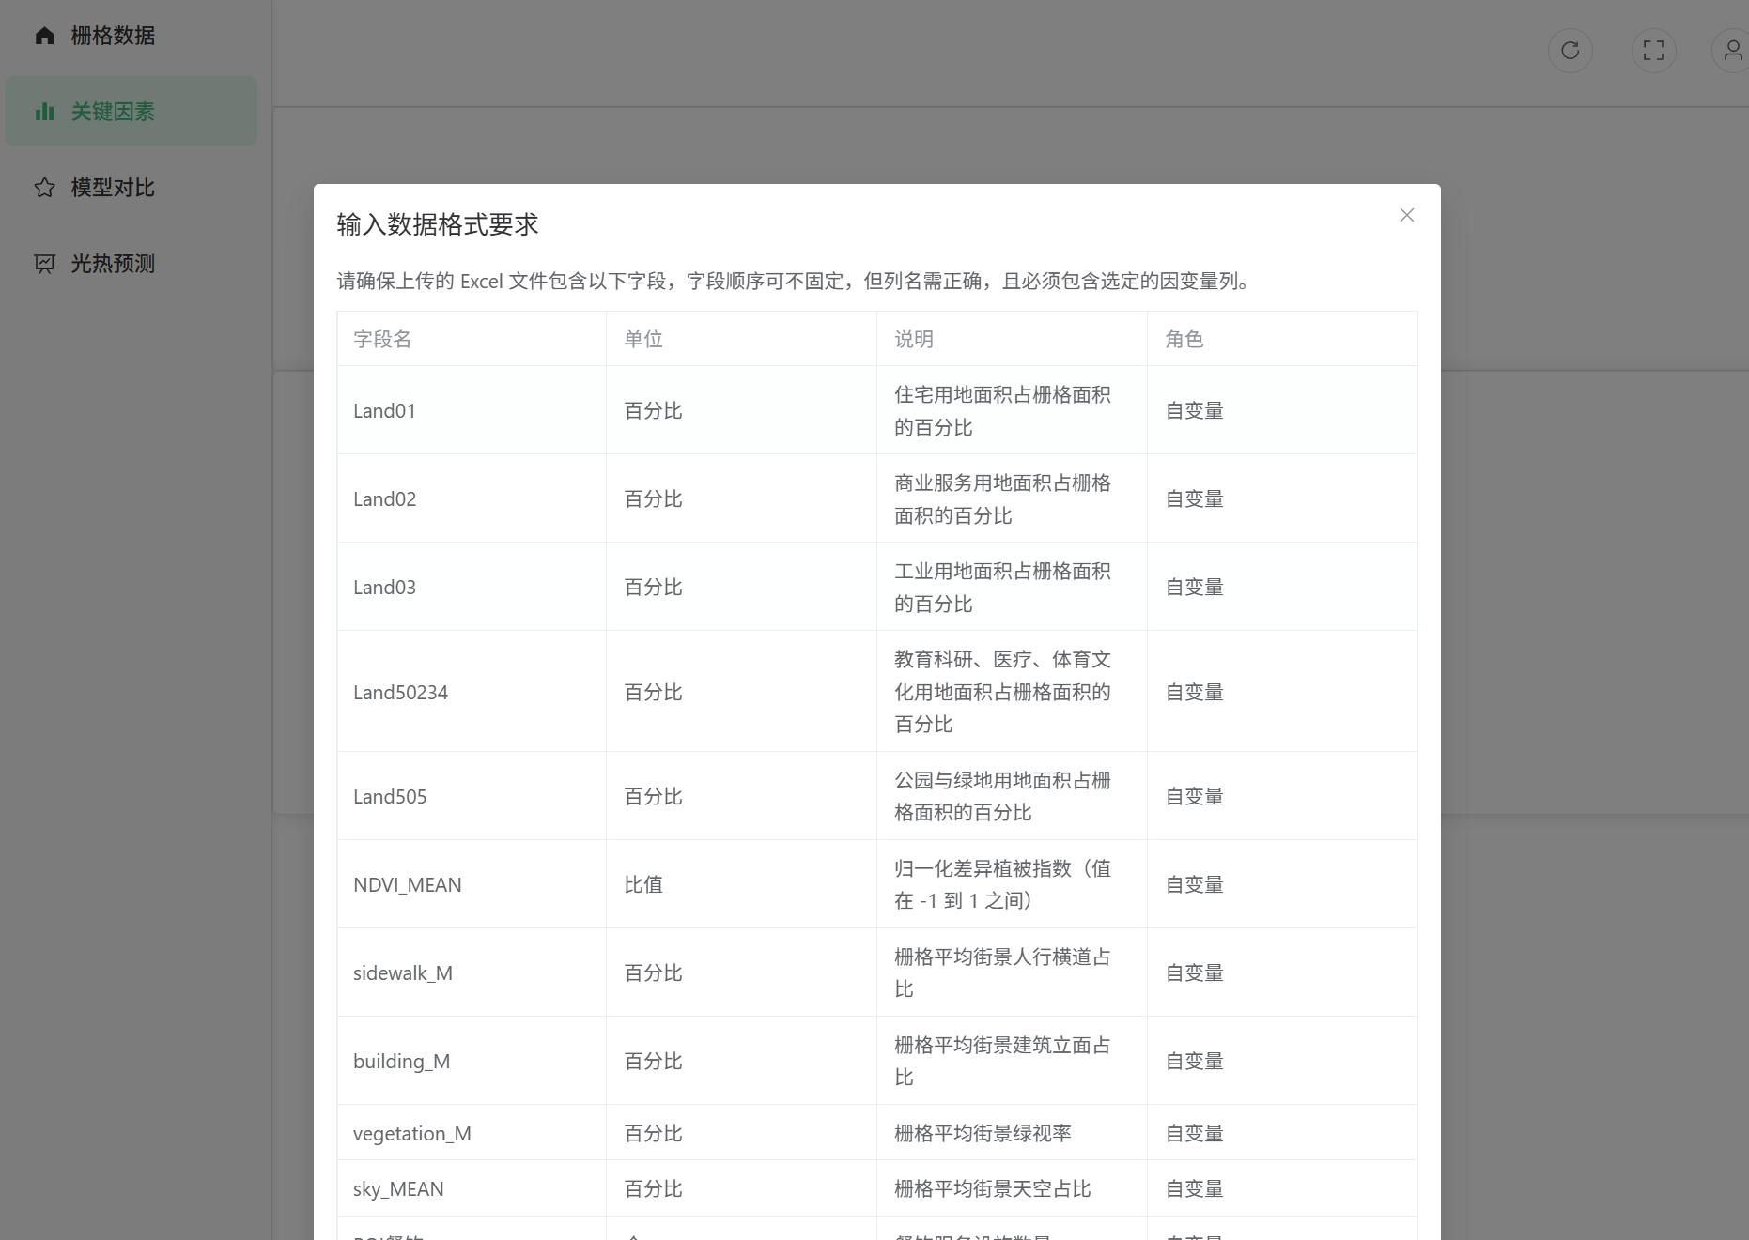

* 1. Grid Data Heatmap Display

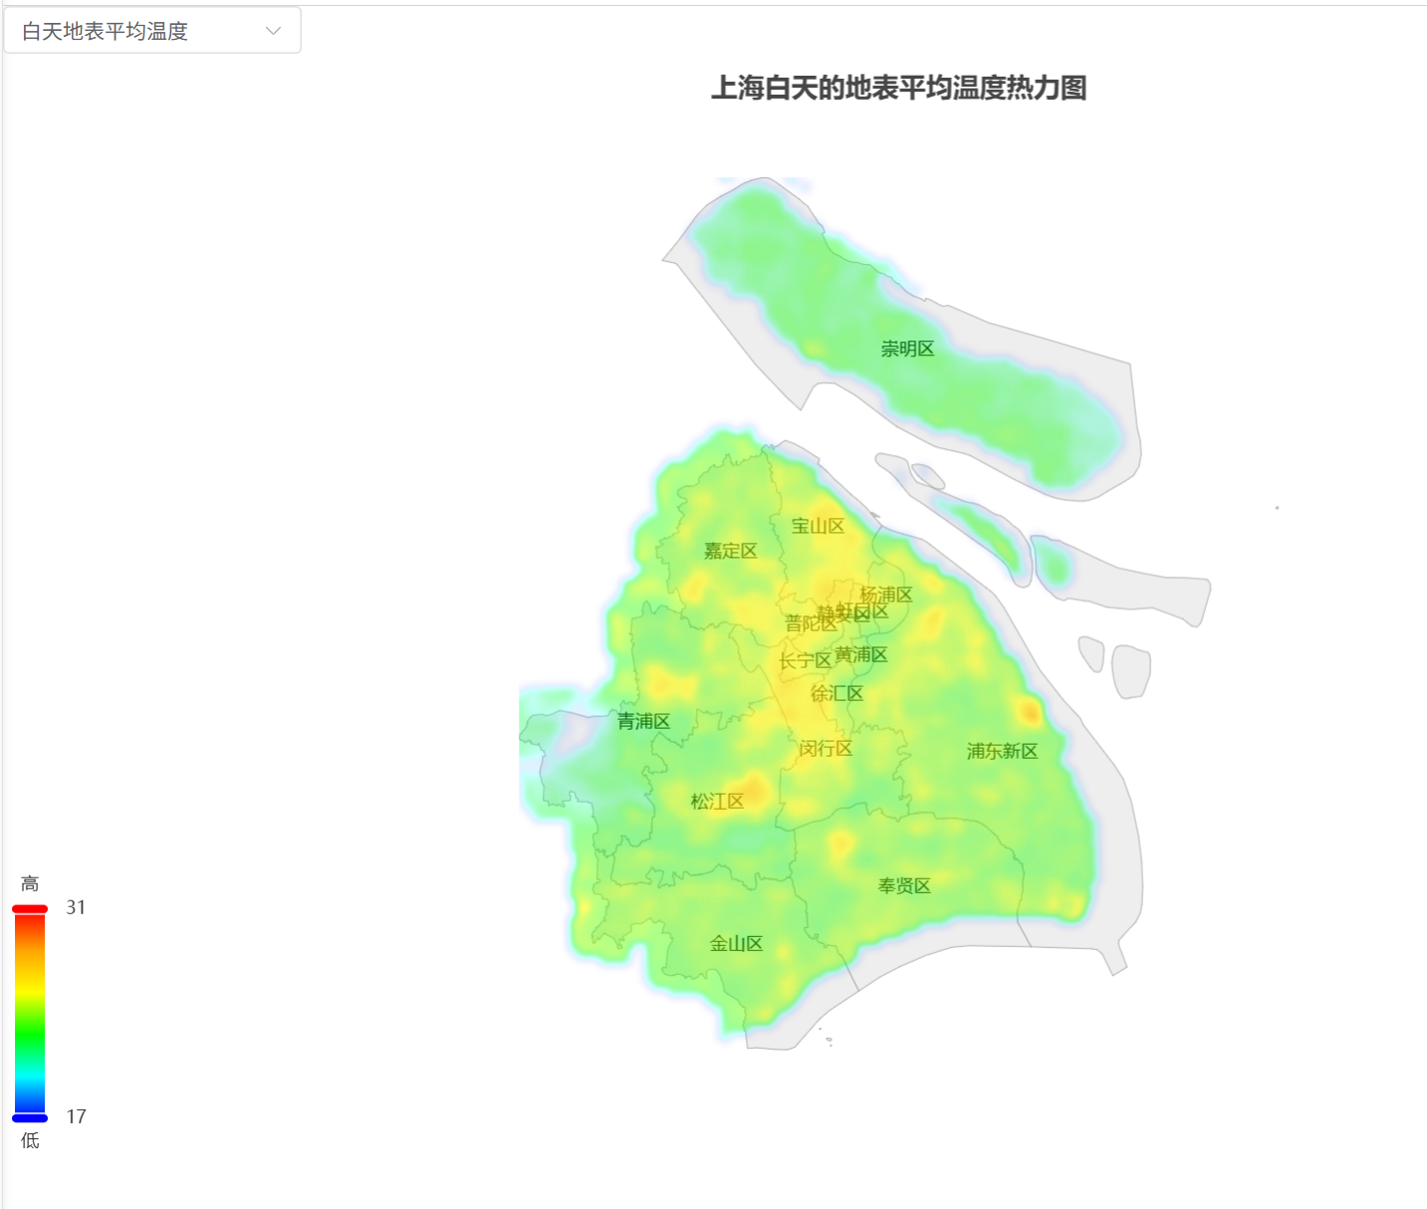

* 1. Model Performance Comparison

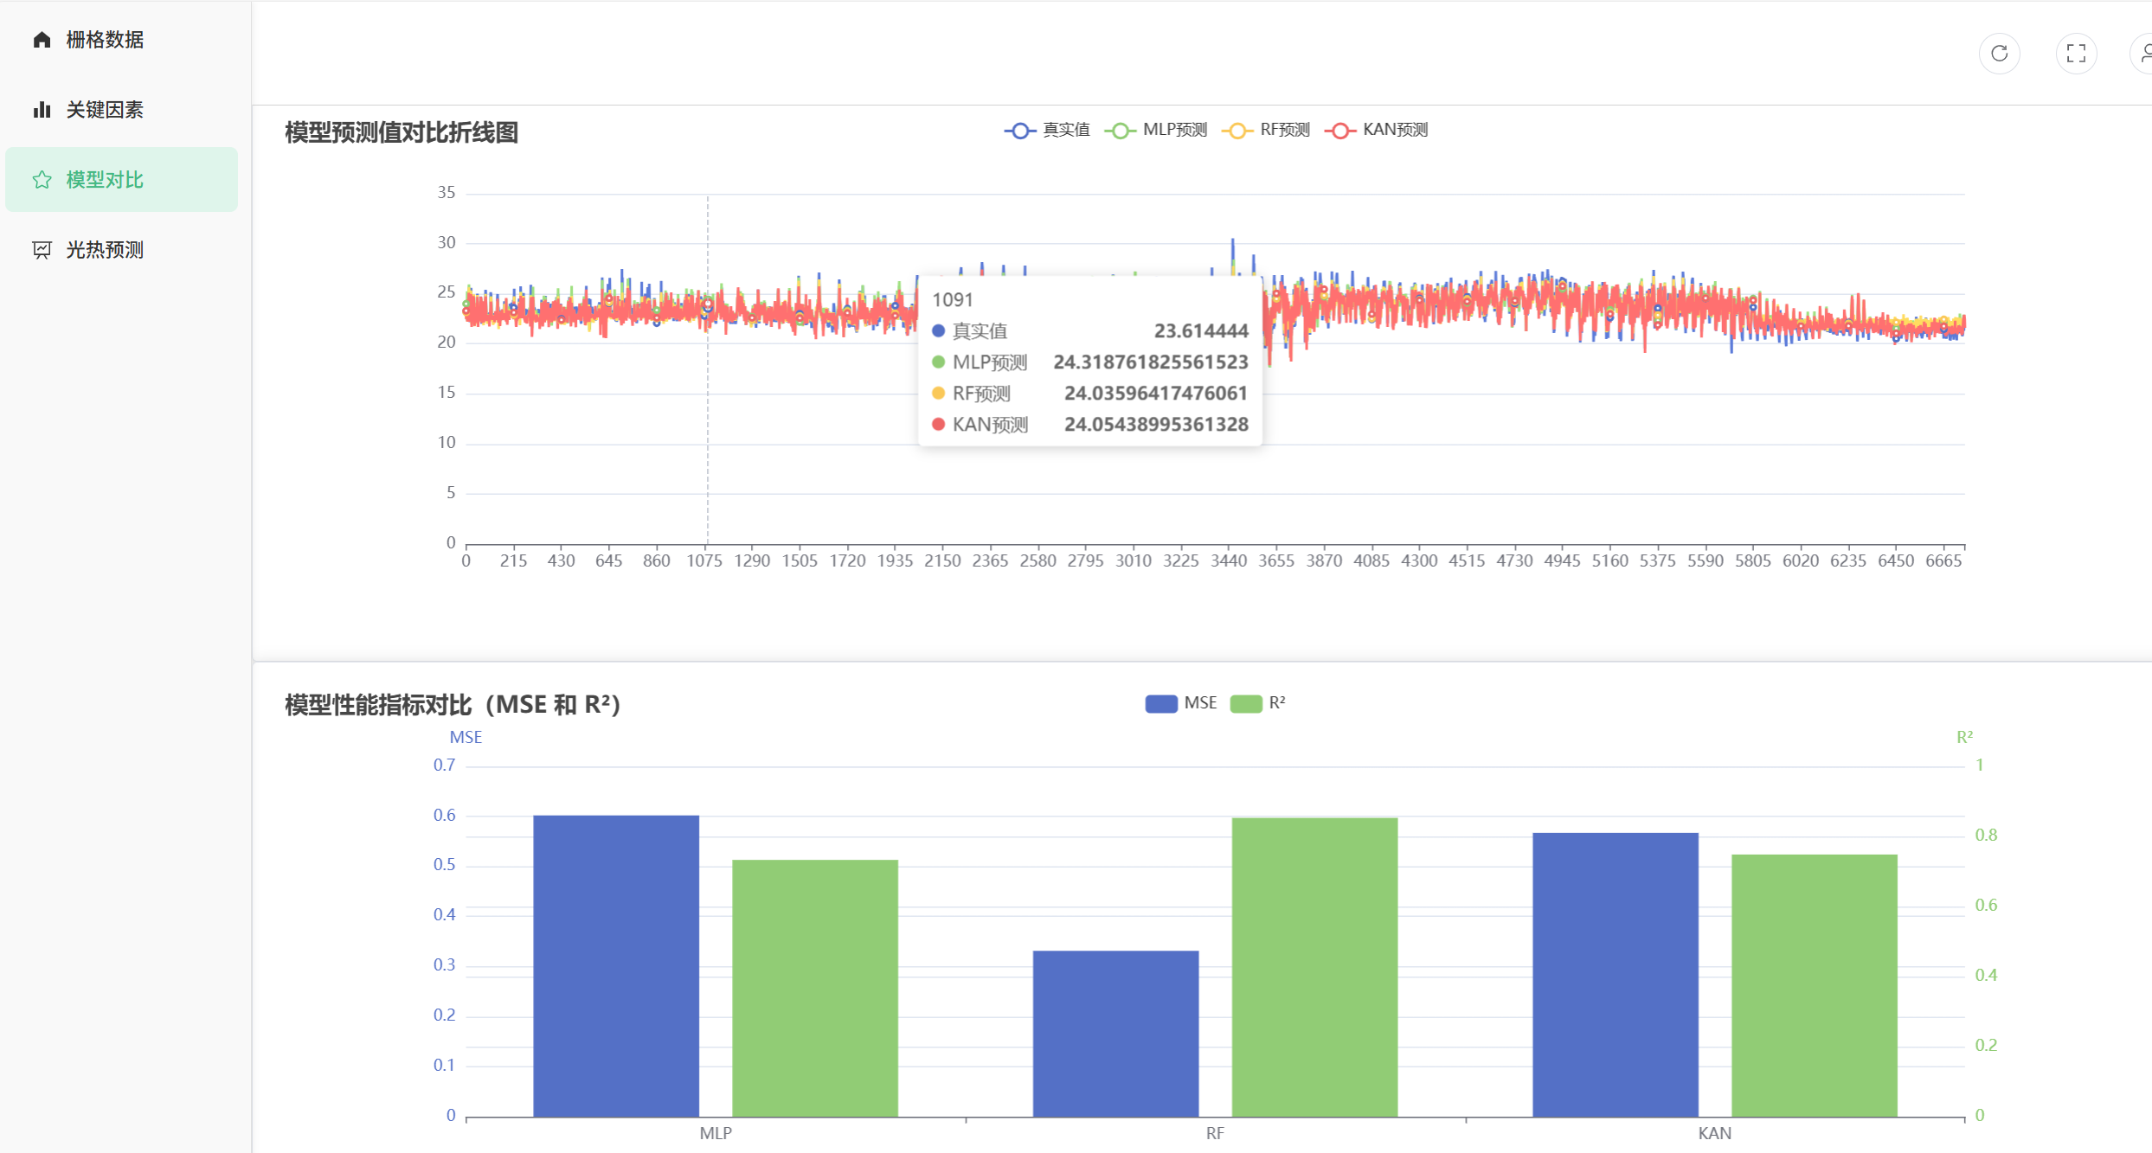

* 1. Predict
     1. Predict results display

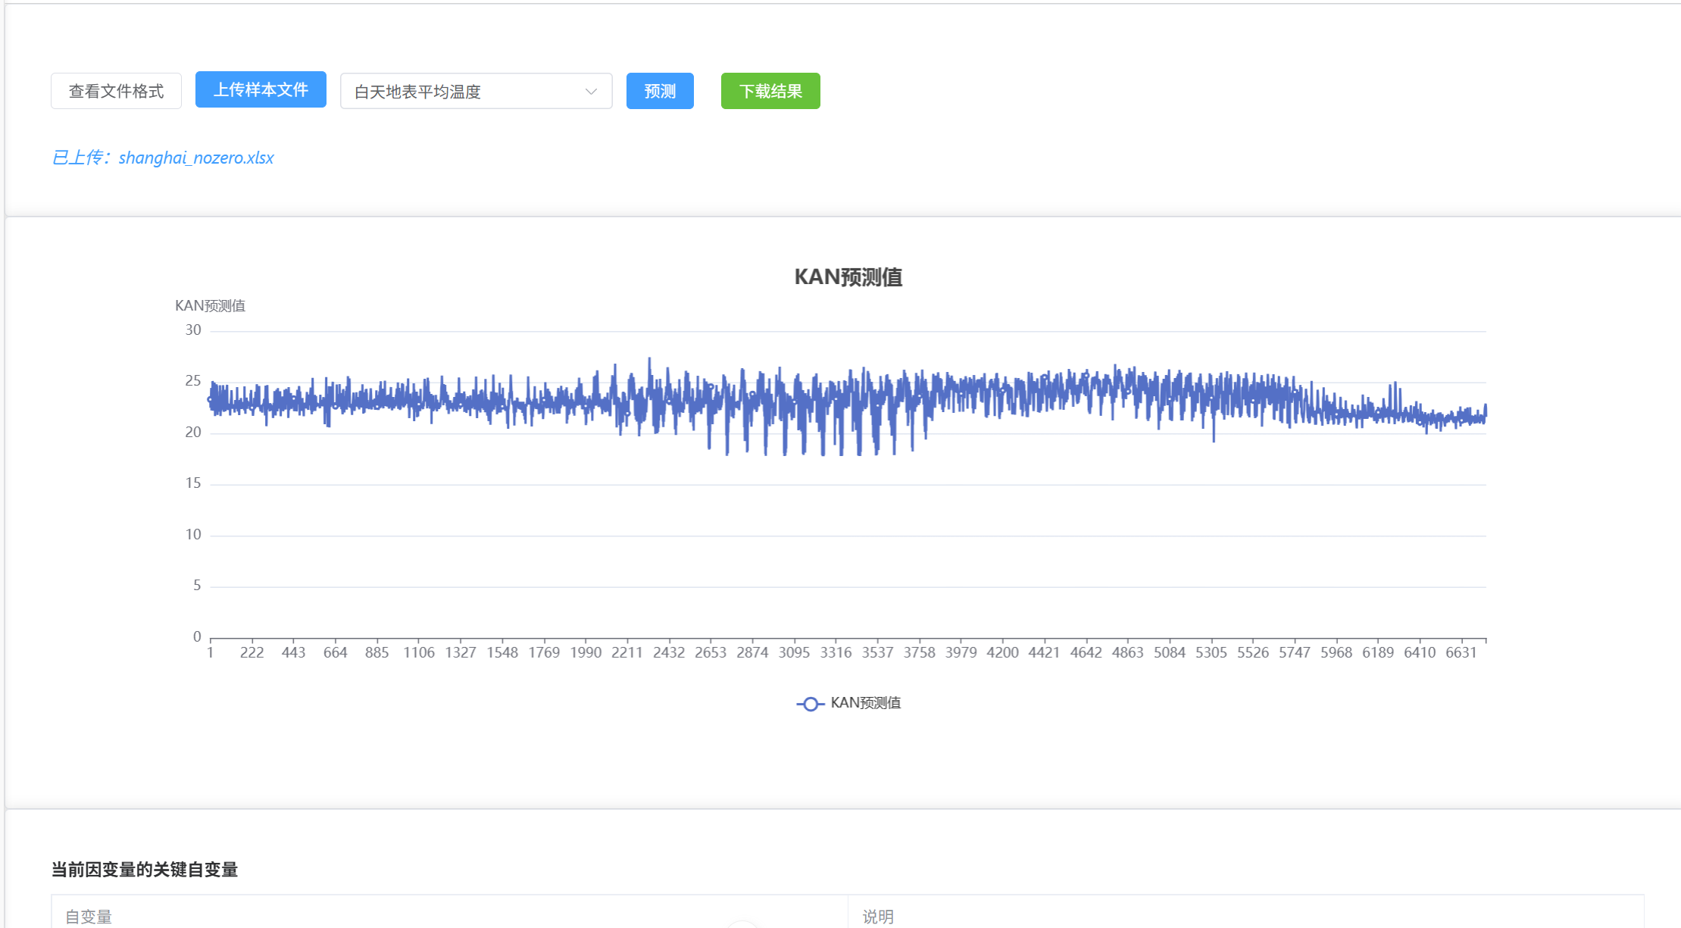

* + 1. Predict results export

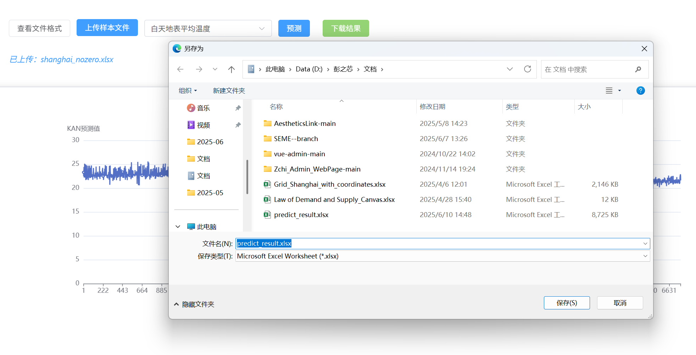

1. Best Practices
   1. System Usage Recommendations

- Access the platform using the latest version of Google Chrome or Firefox browser for best compatibility.

- Before uploading data, users must refer to the "View Data Format" page to ensure that the field name, unit, and format are correct.

- The uploaded data file should be .xlsx or .xls, and the file size should not exceed the system limit.

* 1. Data Interpretation Guidelines

- The change results of dependent variables (such as nighttime light and surface temperature) are affected by multiple factors. It is recommended to verify the stability of the results through multiple rounds of analysis and comparison.

- In "Key Feature Analysis", the higher the score, the greater the impact, but it does not mean the only decisive factor. It should be understood in combination with domain knowledge.

* 1. Troubleshooting Tips

| 问题描述 | 可能原因 | 解决方案 |
| --- | --- | --- |
| 上传文件后无分析结果 | 数据格式错误或缺字段 | 点击“View Data Format”，检查格式和字段是否完整 |
| 分析按钮不可用 | 未选择依赖变量或未上传数据 | 确保上传数据成功且选择了分析目标 |
| 登录失败 | 密码错误或账号未注册 | 使用“Forgot Password”找回密码，或联系管理员 |
| 热力图不显示 | 浏览器版本低或图层加载失败 | 尝试刷新页面或更换浏览器 |

1. Appendices
   1. Frequently Asked Questions

Q: What file formats are supported?

A: Only Excel (.xlsx, .xls) files.

Q: Why is there no analysis result after uploading data?

A: Check if the data format and field names are correct and if the dependent variable is included.

Q: How to reset my password?

A: Use the “Forgot Password” link on the login page.

* 1. Error Message Reference

- “Invalid file format”: Please upload a valid Excel file

- “Missing required field”: Ensure all required columns are present